 

**P7 Moving Forward**

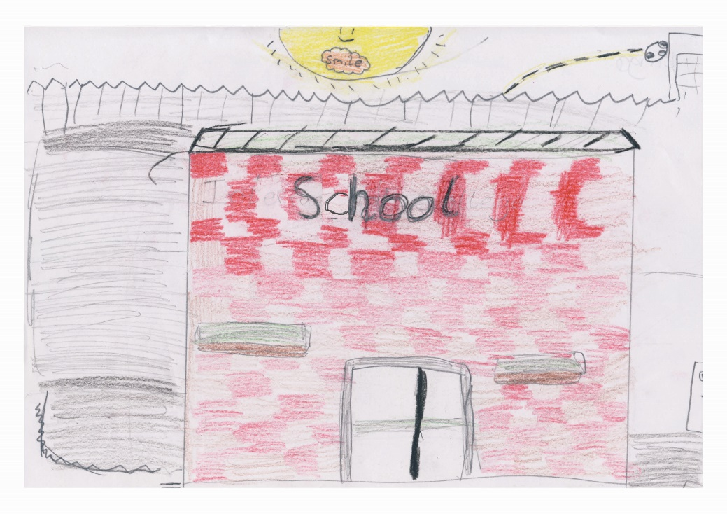

**NAME: _________________________________________**

**SCHOOL:_______________________________________**

**School website:__________________________________**

**DATE:__________________________________________**

**Transport**

Whether you walk to or from school, get a bus or go by car it is always a good idea to learn your route/bus stop before you start your new school.

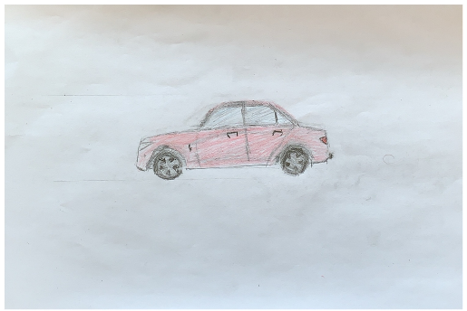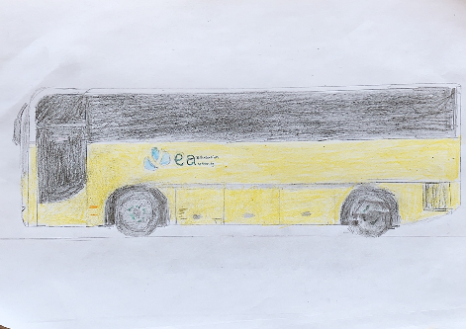

**School Uniform**

You will be getting a new uniform and every school will have their own uniform and PE kit so check the website or correspondence from your new school to check what you need. The good thing about Secondary School is the blazer, there are lots of pockets to put things in.😊

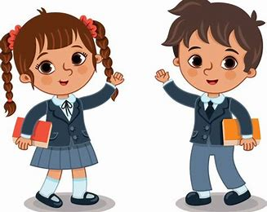

**Stationery**

Prepare for your new school by buying all the stationery you need, especially a good scientific calculator. Here is a general list of some of the stationery you might need.

* Pencil case
* Pencil
* Pen
* Colouring Pencils
* Highlighters
* Rubber
* Ruler
* Sharpener
* Maths Set
* Calculator
* Notebook

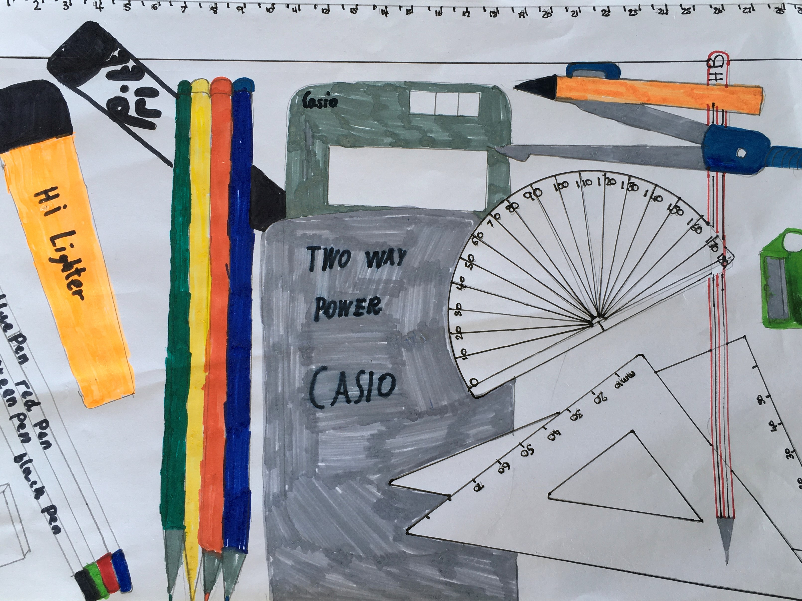

**Classroom**

Unlike Primary School you will be moving from class to class. Each subject will be taught by a different teacher and you get to move from one classroom to another. Many schools will have the subject or teacher name on the door.

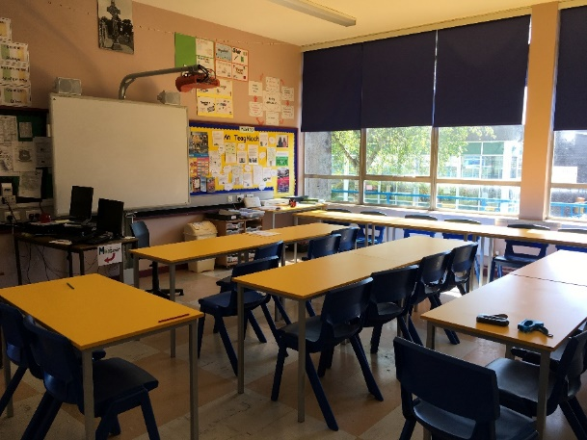

**Corridors**

Corridors are like roads with a lot of traffic on them so do not run along them and keep on one side to avoid bumping into other pupils and staff.

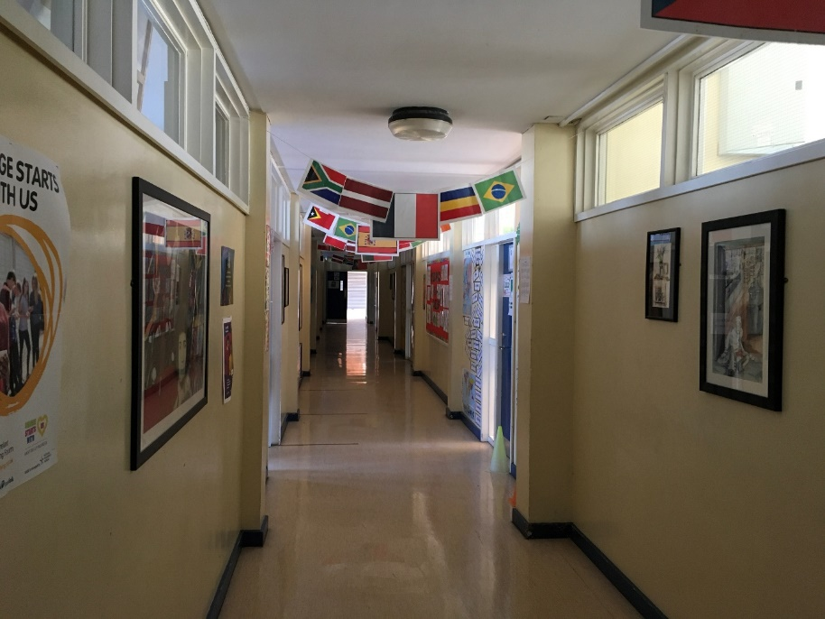

**A Day at School**

Your school day may start between 8.45am and 9.15am depending on your school.

Your day will be broken up into three sections and these depend on how many periods your school has. The following is for 9 periods per day but some schools have up to 11.

Some schools may begin with an assembly.

You may first have to go to your Form Class where your Form Teacher will inform you of any announcements and give out dinner passes.

Periods 1-3

Breaktime

Periods 4-6

Lunchtime

Periods 7-9

(Breaktime and Lunch time will vary from school to school)

Home time 😊

After school there will be a chance to join different clubs and take part in different sporting activities. These clubs are a good way to help you make friends who have similar interests.

* Sports



* Drama
* Music
* IT

**Timetable**

You will be given a timetable which will show you the subjects you have and when, and often the name or initials of the teacher and the classroom are included. It is a good idea to colour code your subjects as this will help you see at a glance which subjects you have each day and also will help you at night to get the books ready for the next day, ensuring you have the correct books/homework with you.

Example of timetable:

|  |  |  |  |  |  |
| --- | --- | --- | --- | --- | --- |
|  | **Monday** | **Tuesday** | **Wednesday** | **Thursday** | **Friday** |
|  | **Maths** | **Technology** | **Maths** | **Geography** | **English** |
|  | **Maths** | **French** | **IT** | **Geography** | **English** |
|  | **English** | **Maths** | **IT** | **LLW** | **IT** |
| BREAK |  |  |  |  |  |
|  | **Science** | **IT** | **Science** | **PE** | **HE** |
|  | **Science** | **Music** | **French** | **Maths** | **History** |
|  | **Geography** | **English** | **French** | **English** | **History** |
| LUNCH |  |  |  |  |  |
|  | **History** | **English** | **PE** | **French** | **RE** |
|  | **Games** | **HE** | **English** | **French** | **Games** |
|  | **Games** | **HE** | **English** | **Drama** | **Games** |

**Break and Lunch**

Times will vary for each secondary school. Lunch will be in a cafeteria where you will have lots of choice. You may pay by card, finger print or money. You can top up your card/account via a machine provided by the school or at the school office.

**School Rules**

Every Secondary School has school rules which are there to keep you safe. If you break the school rules there may be consequences such as detention.

**Why do we have School Rules?**

* + To help keep us safe
  + To keep everyone who works in or visits the school safe
  + To protect the school property
  + To enable school to run smoothly
  + To provide the best possibly education for every pupil

**Support**

Every school has a lot of people who can help and support you with any problem that may be affecting you.

* **Form Teacher** (Your Form Teacher will have most contact with you and is there to help so don’t worry about approaching them with any problems you may have)
* **Year Head** (Again your Year Head is there to help with any worries so don’t feel afraid to approach them)
* **Designated Teacher** (Your school will have specific teachers who are responsible for child protection and there will be photos of them in your school. Go to them if you find yourself fearful for any reason or bullied)
* **School Counsellor** (every Secondary School has a Counsellor who comes in once a week and you can ask to be referred or some schools have a box to put your request in and it remains anonymous)

* **Education Welfare Officer (EWO)** (There is a link EWO in every school)
* **Office Staff**

**Enjoy your Secondary School**



