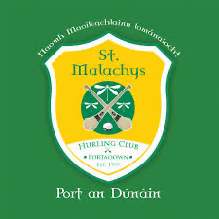
St Malachy’s Hurling Club is based at The Moss on the Moy Road in Portadown.

We are always looking for and encouraging new members/players to join our teams – Our underage groups range from U5.5’s to U15’s.

All underage training up to U11.5’s – Sundays 10-11am & Thursdays 6-7pm
U13’s training Mondays & Fridays 7-8pm
U15’s training Wednesdays & Fridays 7-8pm

Contact can be made through Leon 07917 141444, email secretary.stmalachysportadown.armagh@gaa.ie, our Facebook page or any of our committee members.

