Hello Guardians, boys and girls,
We are now beginning week 2 of our stay at home learning and I have thoroughly enjoyed seeing photographs of you all busy working from home via the school website. Keep posting please.
Learning takes many different forms and in our day to day routines, the development of life skills is vital to help us find new ways of thinking, problem solving, decision making, building confidence as well as communicating and cooperating with others. These essential skills help us to grow into caring, responsible adults who can meet the challenges of everyday life. These current times are certainly challenging. Therefore, we should take this opportunity to learn new skills whether it be baking buns, cooking, learning a new instrument, making your bed, painting a shed or generally helping mum and dad out at home - all vitally important.
Reading for pleasure, as we know, makes a big difference to children’s educational performance. Our children are constantly building their reading skills along with their love for reading using Accelerated Reading (AR) all year long. These experiences can also be enjoyed at home. We would encourage you to spend time reading silently every day. Any books read at home, provided there are quizzes to accompany these, will be credited to your personal account using our school AR website at:
www.ukhosted71.renlearn.co.uk/2252962
Individual login and password details are also needed. www.arbookfind.co.uk will enable you to source books with existing quizzes.
A new feature of AR is myON. It has over 6000 online books you can access and quizzes taken on these books will also be credited to your AR account. There are a lot of non-fiction books on myON and I know my own child is loving these. We have set up an email especially to help and support parents who are currently experiencing difficulties accessing AR at YourARfriend@yahoo.com. Please don’t hesitate to contact us with any queries.
I am also able to track children’s progress from home and each week we intend to focus on children who are achieving in different aspects of AR. We are beginning this week with the ‘most words read in a week’ and the top 5 names will be posted on Monday 6th April. Maybe we have or will have a word millionaire among us to celebrate - that would be wonderful! So please take this opportunity to read every day and any rewards or targets met during your time at home will be presented at a very special assembly when we finally return to school. What a celebration that will be!!! However, at present, our main aim is to stay at home and keep safe.
I am also setting a challenge for all children in P1-7, parents, teachers and classroom assistants. This is your mission should you choose to accept it.
DESIGN A BOOK CHARACTER
- You will need to be very creative to make a book character of your choice.
- The 3D book character can be made from a range of materials such as cardboard boxes, plastic cartons, in fact anything from your recycling bin. What you use is entirely up to your creative juices. My family used eggs in the run up to Easter.
- You can paint, colour, use material, googly eyes, the list is endless.
- Get parents involved, make it a family affair and most important of all, HAVE FUN!!!!
Please send photos or short videos of your finished designs to:
stjohnthebaptistpsportadown@gmail.com
These will be posted to our website. Remember to include why you chose your character, who helped you and your favourite part of the activity.

I’m looking forward to seeing your creations. We as a family had great fun today making our book characters.
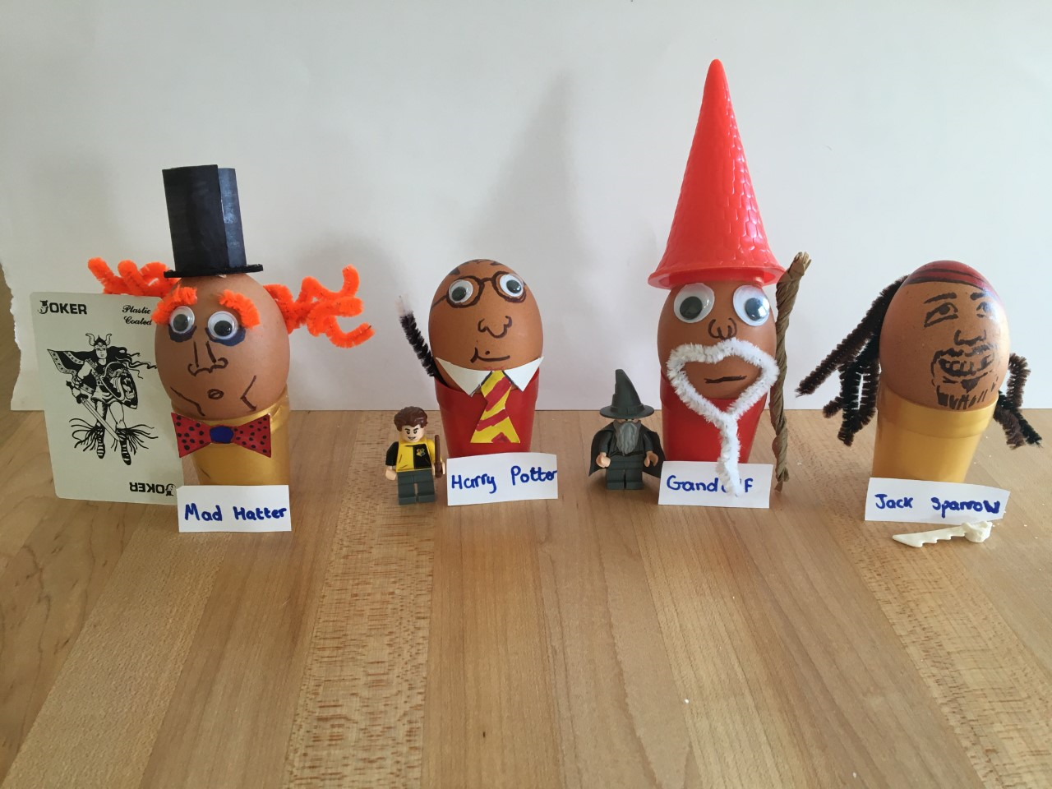
To you and your families, from our school community, we have you all in our thoughts and prayers. We miss you and are looking forward to having you back in school along with your friends laughing and learning together.
Take care. God Bless.
Mrs Coleman
Literacy coordinator.

