|  |  |  |  |  |  |
| --- | --- | --- | --- | --- | --- |
|  | **ST John the Baptist PS School Lunch Menu Jan 22**  **Monday** | **Tuesday** | **Wednesday** | **Thursday** | **Friday** |
| **Week 1 – 06/01/22** |  |  |  | Fish fingers or Mac & cheese, mashed potato, baked beans, coleslaw, sweetcorn  Chocolate Muffin | Hot dog or homemade Margherita pizza, peas, tossed salad, chips, mashed potato  Flakemeal biscuit |
| **Week 2 – 10/01/22** | Steak burger or pasta twists with homemade tomato sauce and sliced chicken, gravy, broccoli florets, baton carrots, mashed potato  Shortbread biscuit | Homemade Margherita pizza or breast of chicken curry with boiled rice & naan bread, sweetcorn, pasta twists, salad selection  Fresh fruit | Fresh breaded fish goujons or chicken crumble, baked beans, garden peas, mashed potato, salad selection  Jelly pot | Roast chicken or savoury mince, traditional stuffing, gravy, cauliflower cheese, fresh diced carrots/parsnips, mashed potato  Muffin | Chicken nuggets or baked potato with chicken & cheese, sweetcorn, chips, baked potato, salad selection  Ice-cream tub |
| **Week 3 –** **17/01/22** | Breaded fish fingers or pasta bolognaise, baked beans, garden peas, mashed potato  Flakemeal | Homemade salt & chilli or traditional chicken goujons, or mac & cheese, broccoli florets, mashed potato, salad selection  Raspberry ripple ice-cream | Oven baked sausages or sweet & sour chicken with rice, garden peas, baton carrots, mashed or baby boiled potatoes  Fresh fruit | Roast turkey or salmon fish cake, traditional stuffing, gravy, fresh carrot/parsnip, mashed potato  Jelly pot | Steak burger or homemade lasagne,  Sweetcorn & peas, chips, baked potato, salad selection  Ice-cream tub |
| **Week 4 –**  **24/01/22** | Breast of chicken curry with boiled rice & naan bread or oven baked sausage, baton carrots, garden peas, gravy, mashed potato  Fresh fruit | Spaghetti Bolognese or fresh bread fish fillets, broccoli & cauliflower florets, mashed potato  Jelly pot | Roast breast chicken or brown stew, traditional stuffing, gravy, diced turnip, fresh baton carrots, mashed potato  Chocolate muffin | Homemade salt & chilli or traditional chicken goujons or chicken tortilla wraps, baked beans, sweetcorn, salad selection, mashed potato  Flakemeal biscuit | Homemade Margherita pizza or fish fingers, sweetcorn, traditional champ, chips, salad selection  Ice-cream tub |
| **Week 5 – 31/01/22** | Breaded fish fingers or spaghetti bolognaise, baked beans, medley of fresh vegetables, mashed potato  Fresh fruit |  |  |  |  |
| **Menu choices subject to deliveries, Fresh fish may contain bones**  **Rice, pasta and gravy can be served daily** | | | | | | |

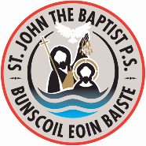

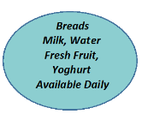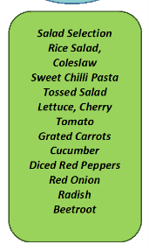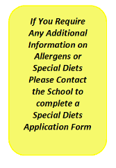2